Upcoming Events:

October :

Fire Safety Week (and a visit from our local Fire Department!)

November:

Parent/Teacher Conferences

Dear Families,

Welcome to Southern Maine Children’s Academy! We are excited to start this new school year with you and and your children! Here are a few housekeeping items as we start our new school year:

* Please remember to sign your child in and out each day.
* Every child’s Admission Record, including the green emergency card and immunization record should be returned as soon as possible. We are required by law to have this information in your child’s file.
* Remember to pack a change of clothing so that we can change your child in the event they become messy or have an accident.
* We are a nut-free school due to severe allergies in the building. Thank you for your cooperation with this important matter. Please let us know if you need ideas for other healthy items that your child may enjoy at snack and lunchtimes.



SMCA Newsletter

Fall 2015

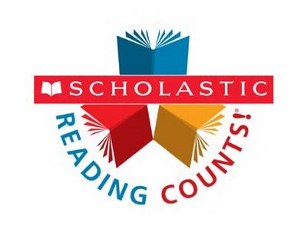

Later this month, you will begin to receive Scholastic Book Orders. Scholastic is a great resource for inexpensive books. As a bonus, SMCA will receive points for every order to further build our school library.

You may order using the form provided, or online using our exclusive code.

Our code is: **JFFY6**

Staff Contact Information:

Phone: 207-893-1599

Director: Jacki Billington

[jbillington@southernmainespeech.com](mailto:jbillington@southernmainespeech.com)

Team Leader: Tammy Hohn

[Tammyh@southernmaineacademy.com](mailto:Tammyh@southernmaineacademy.com)

Lead Teachers:

Yellow Room-Maria Remington

[mariar@southernmaineacademy.com](mailto:mariar@southernmaineacademy.com)

Blue Room- Theresa Amos

[theresaa@southernmaineacademy.com](mailto:theresaa@southernmaineacademy.com)

Orange Room-Megan Belisle

[meganb@southernmaineacademy.com](mailto:meganb@southernmaineacademy.com)

Rainbow Room- Kate Sorokin

[kates@southernmaineacademy.com](mailto:kates@southernmaineacademy.com)